I233018
SEB
Abdul Basit

LAB1:

Task I: Create a new directory named new_dir.

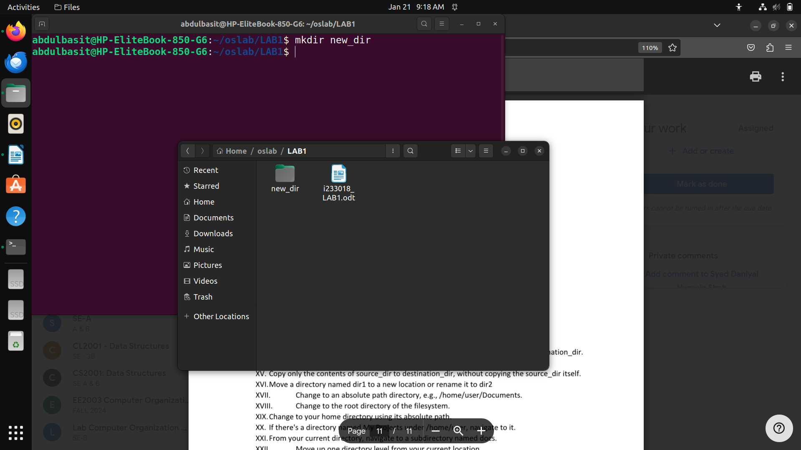

TaskII. Create a nested directory structure parent/child/grandchild.
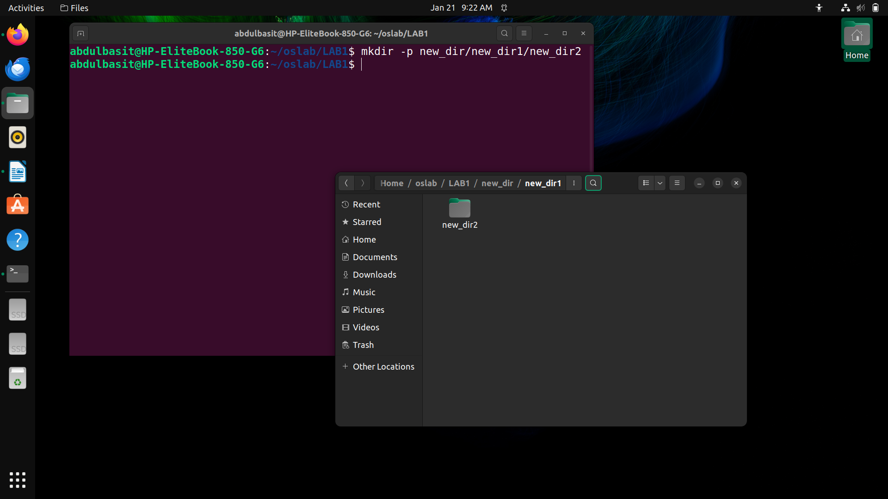
TaskIII. Create multiple directories dir1, dir2, and dir3 in one command.
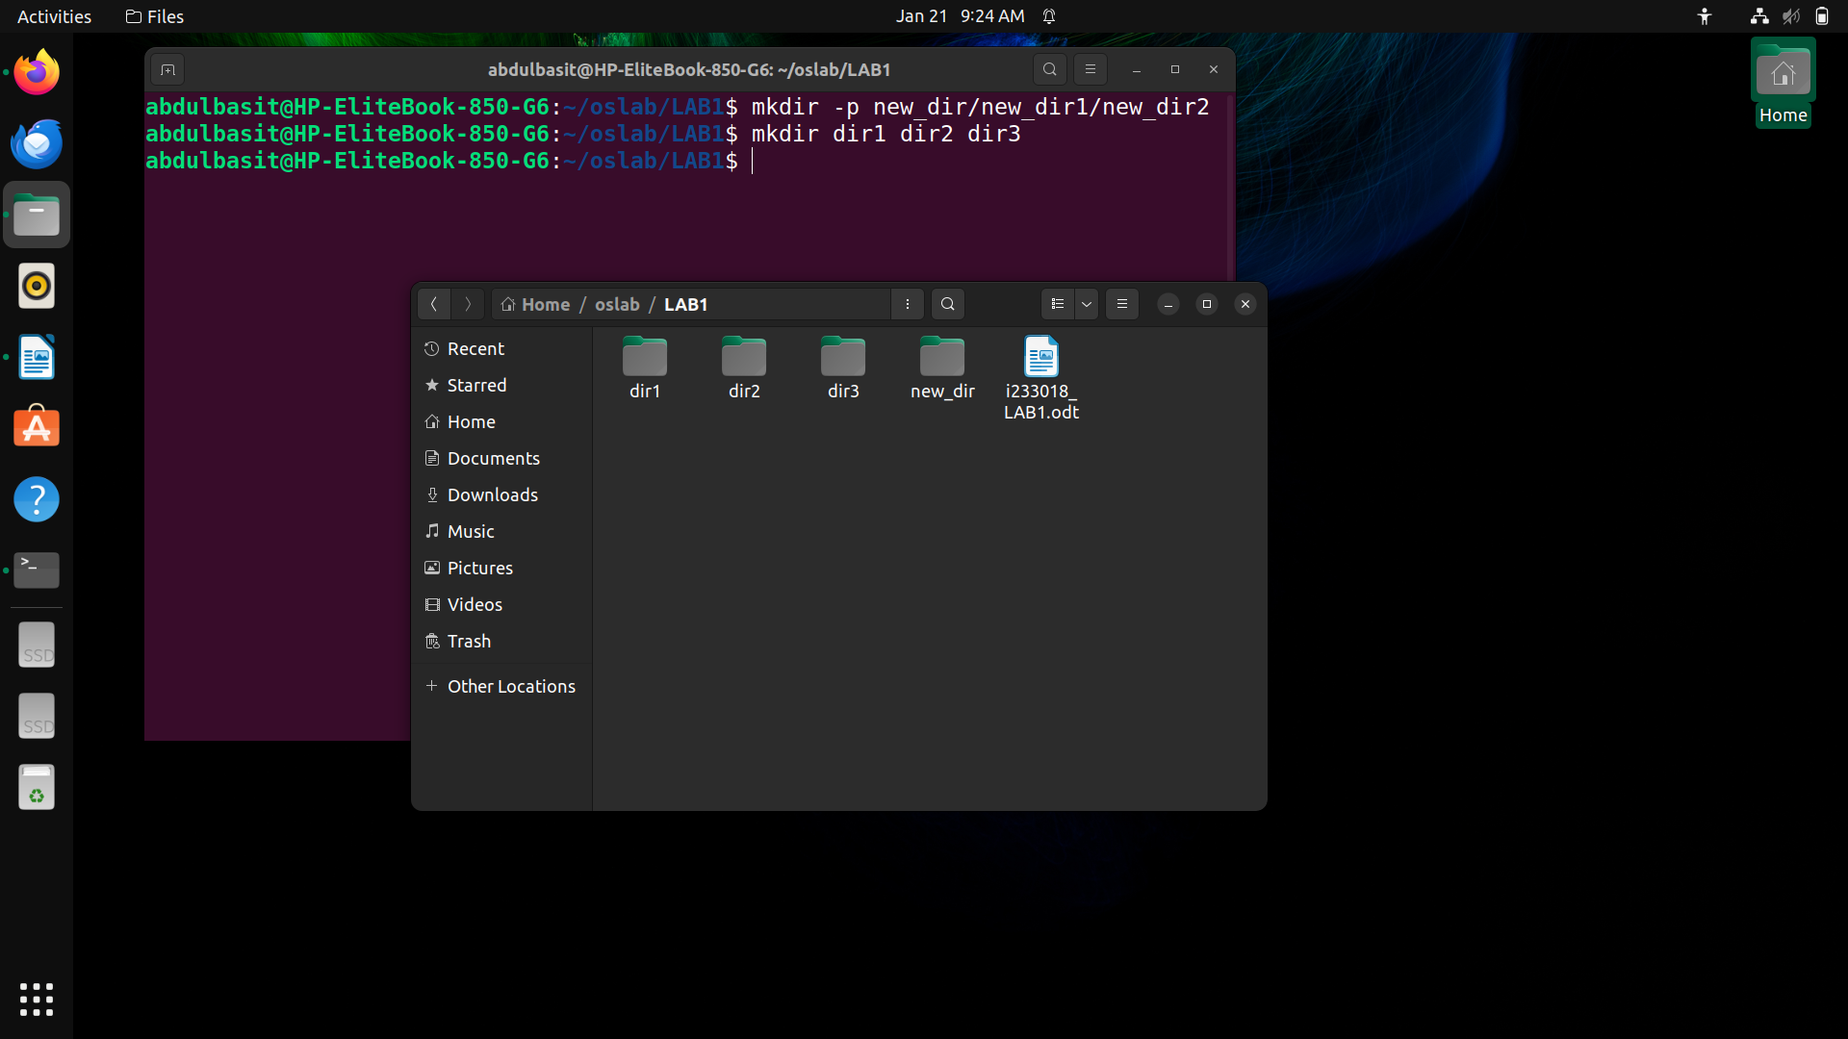

TaskIV. Remove an empty directory named new_dir.
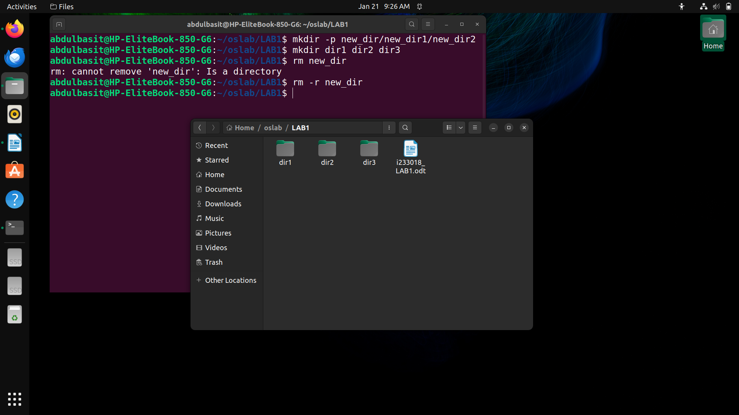
TaskV. Try to remove a directory named non_empty_dir.

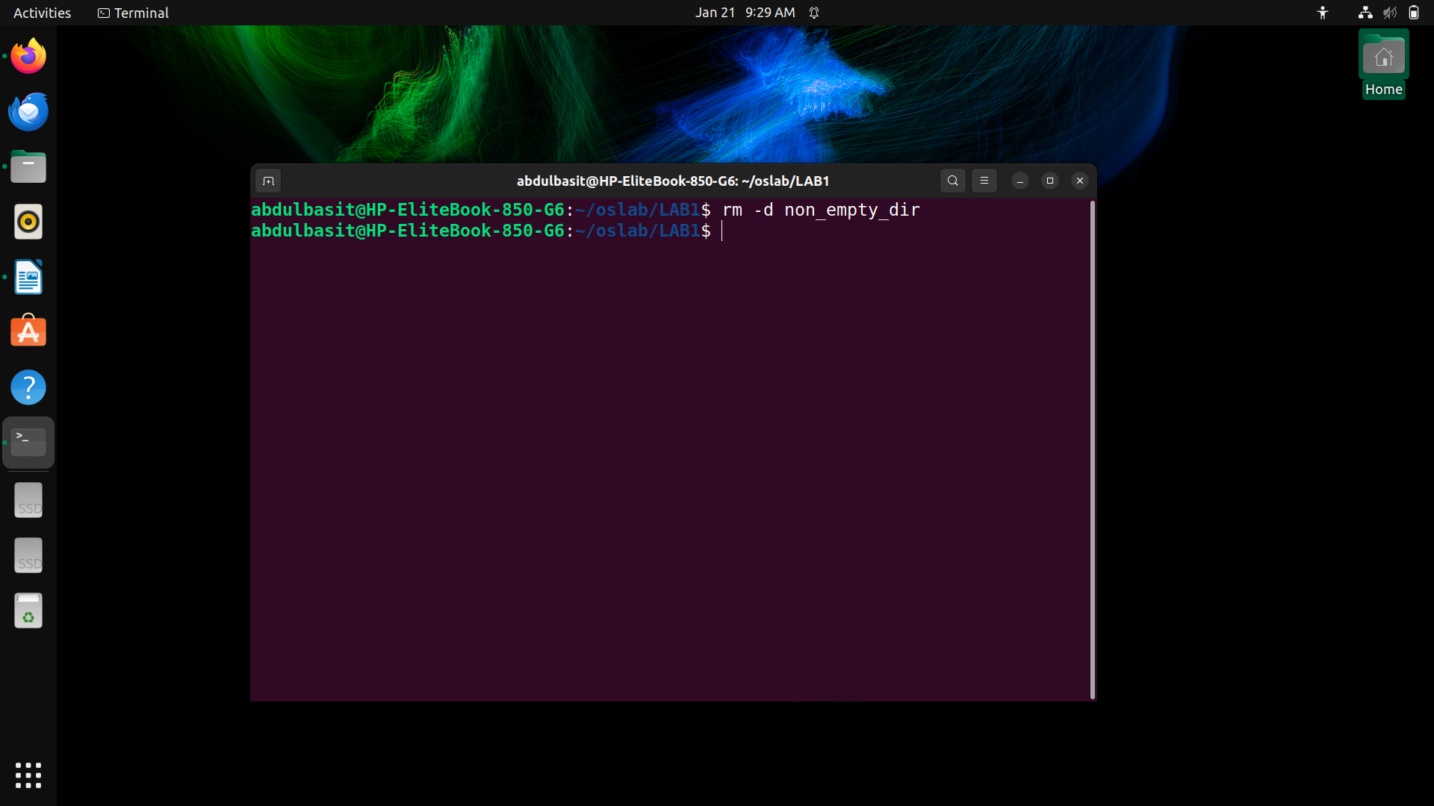

TaskVI. Remove a file named file1.txt.
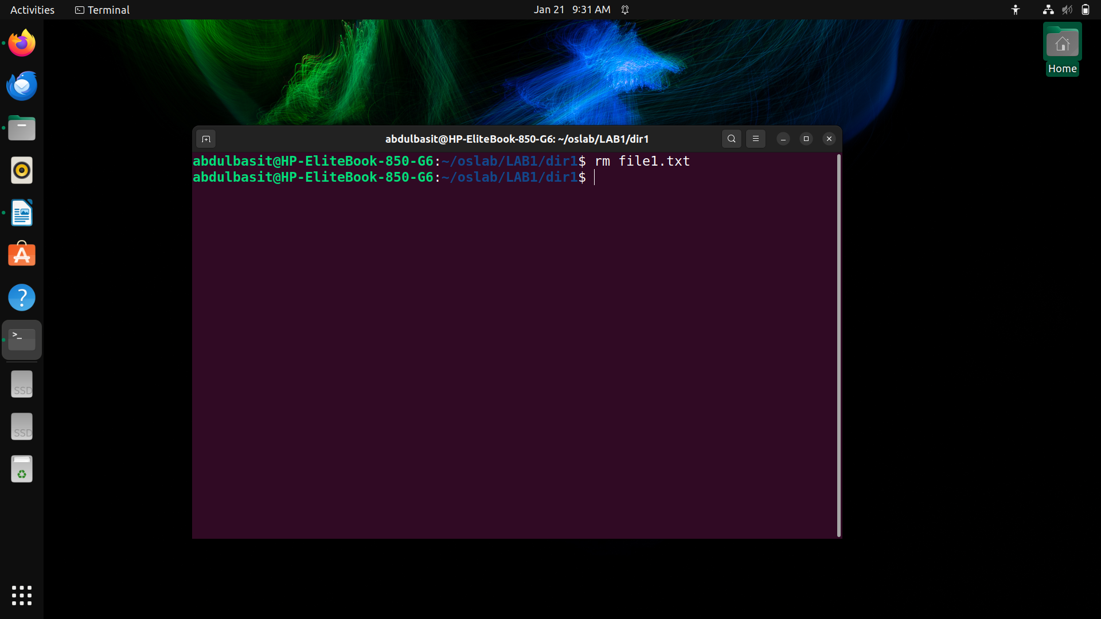
TaskVII. Remove a directory named dir1 and all of its contents.

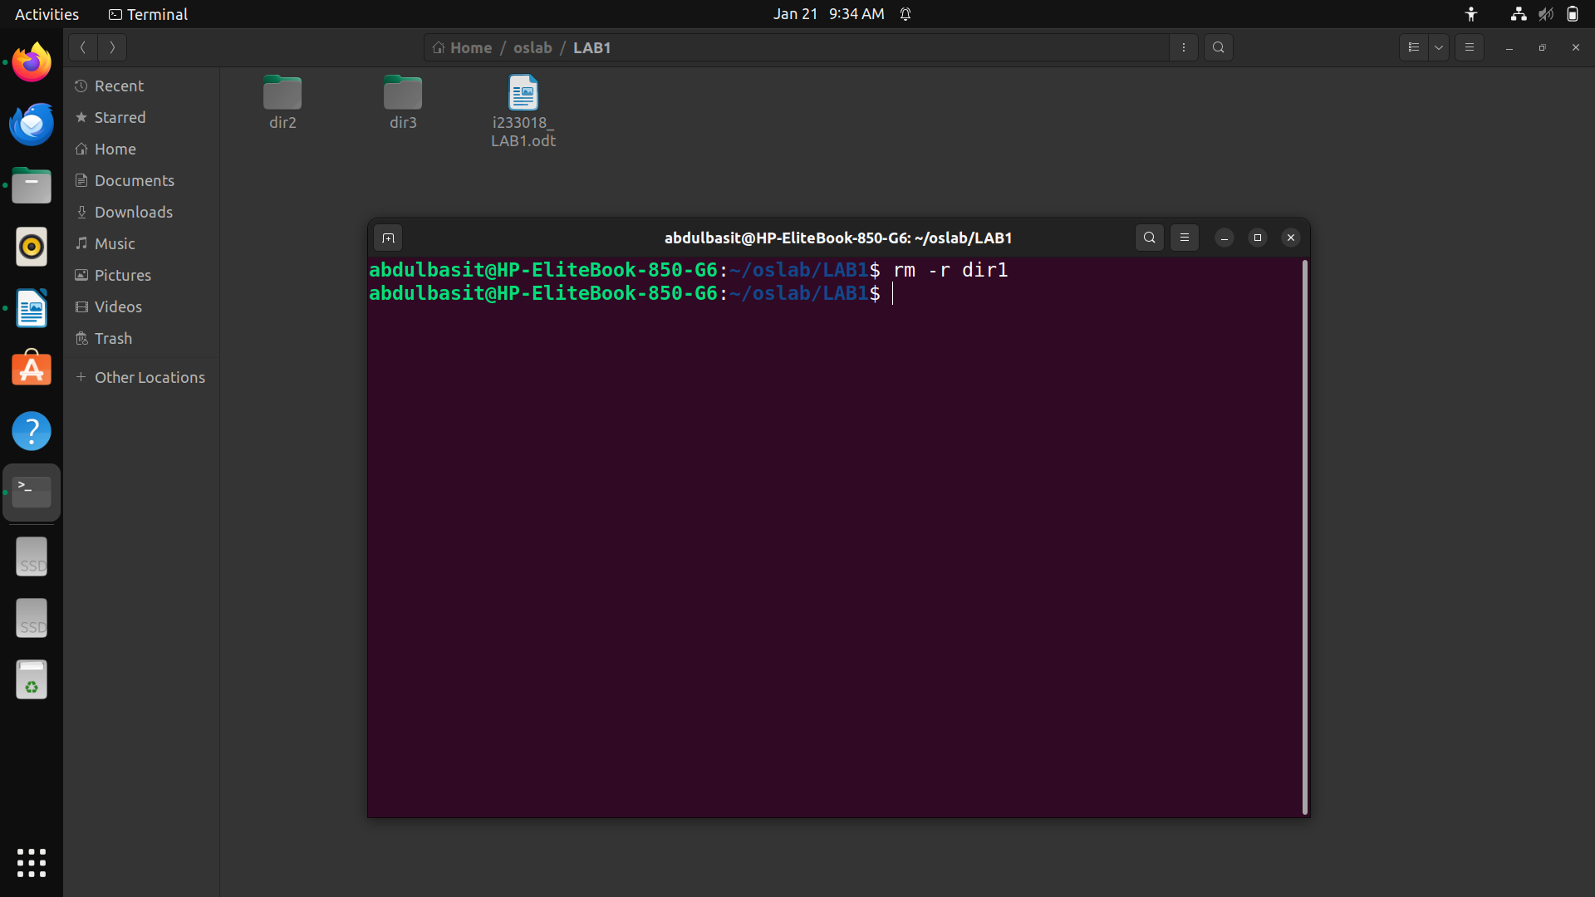
TaskVIII. Remove an empty directory named dir2.
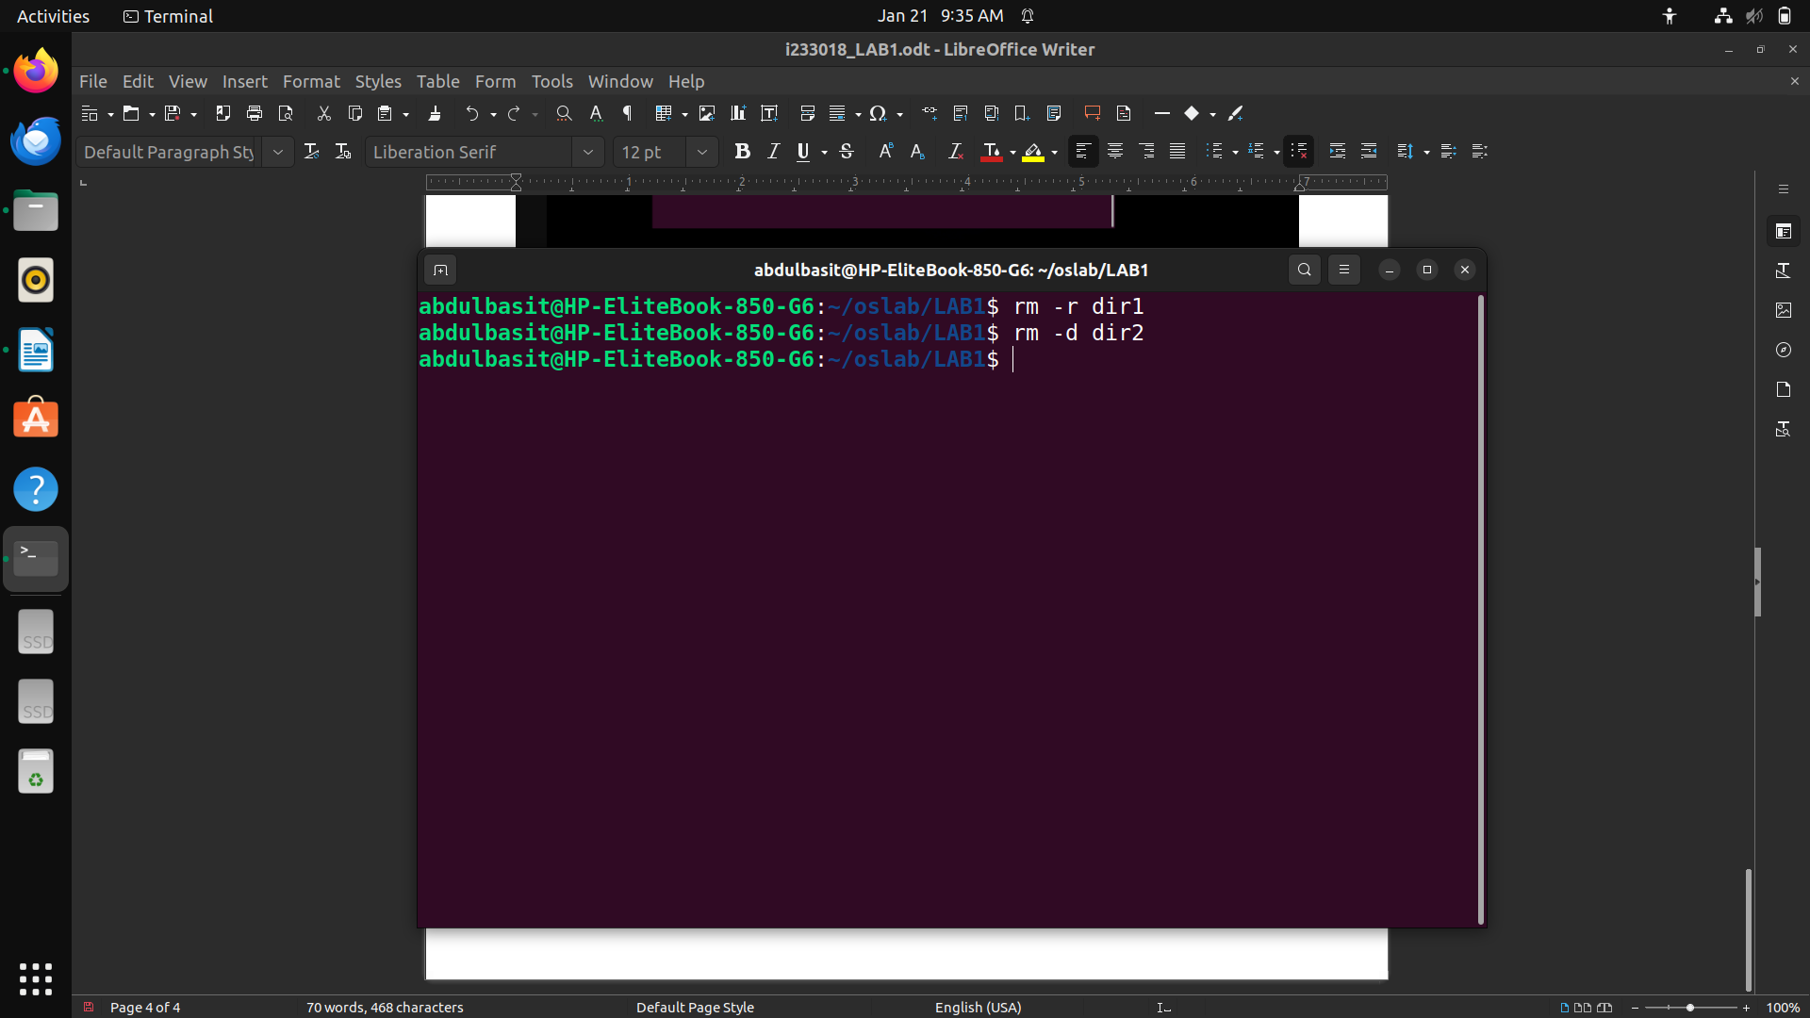
TaskIX. List all files in the current directory, including hidden files (those starting with a dot).

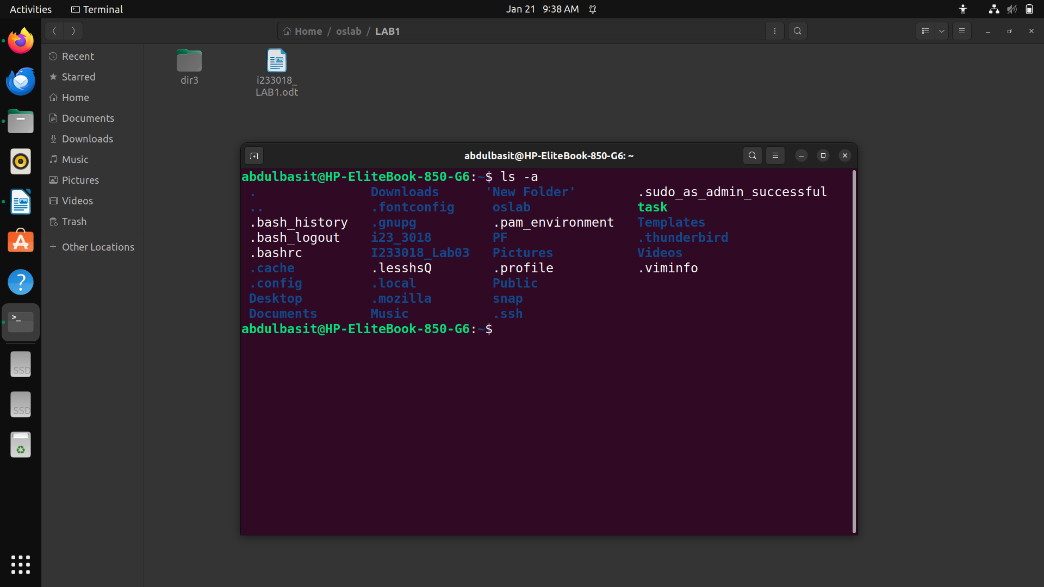

TaskX. List files sorted by modification time, with the most recently modified files first.

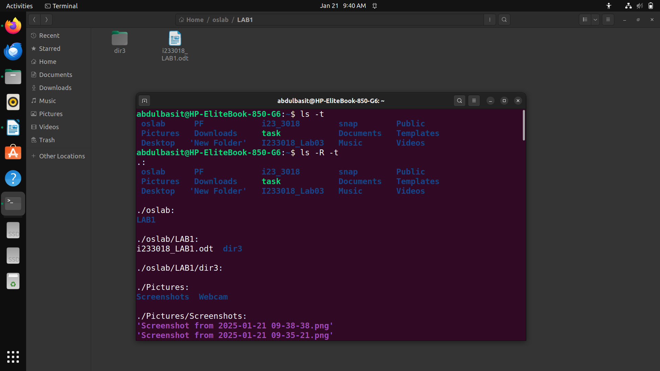
TaskXI. List files sorted by size, with the largest files first.
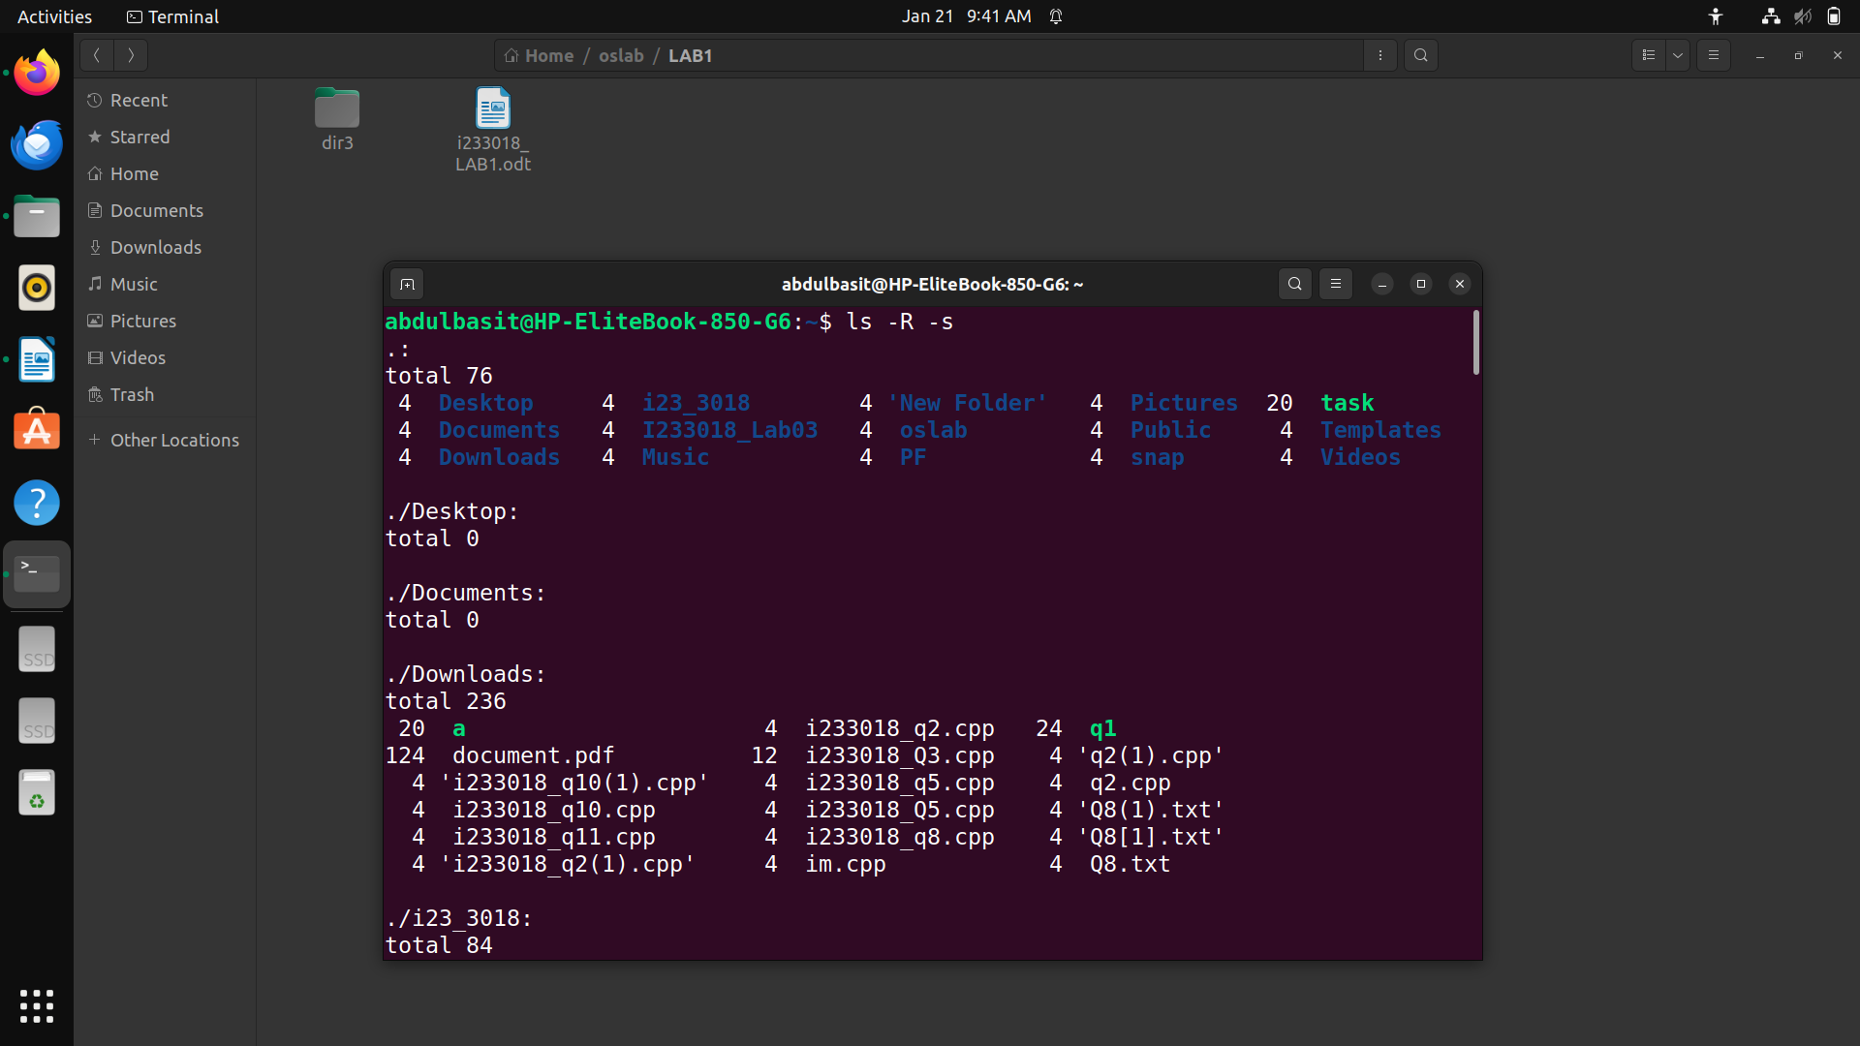

TaskXII. Copy a file named file1.txt to a new file named file2.txt.
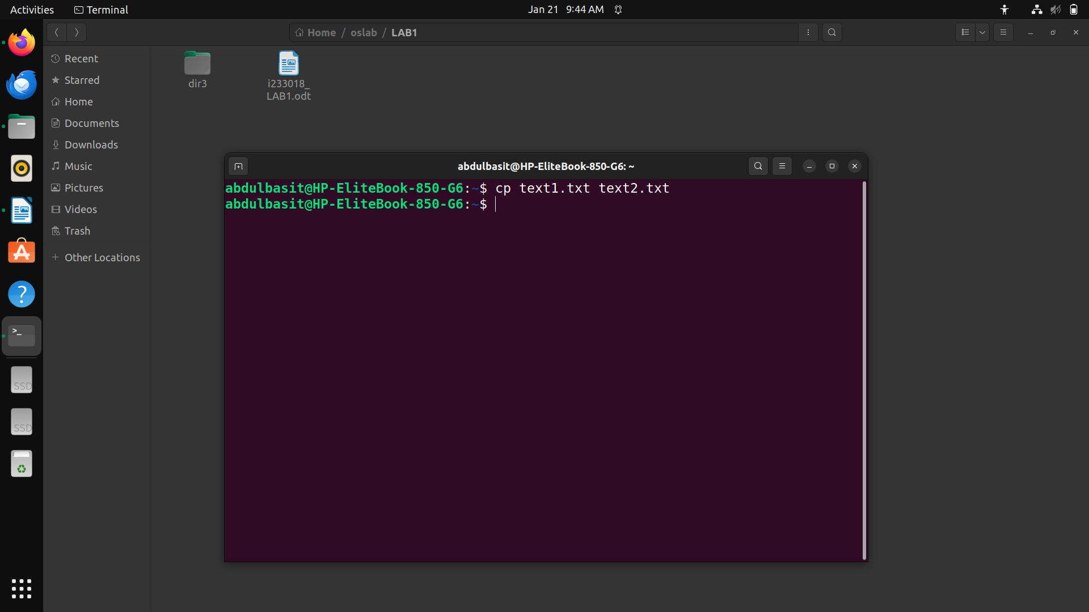
TaskXIII. Copy a directory named source_dir and its contents to a new directory named destination_dir.
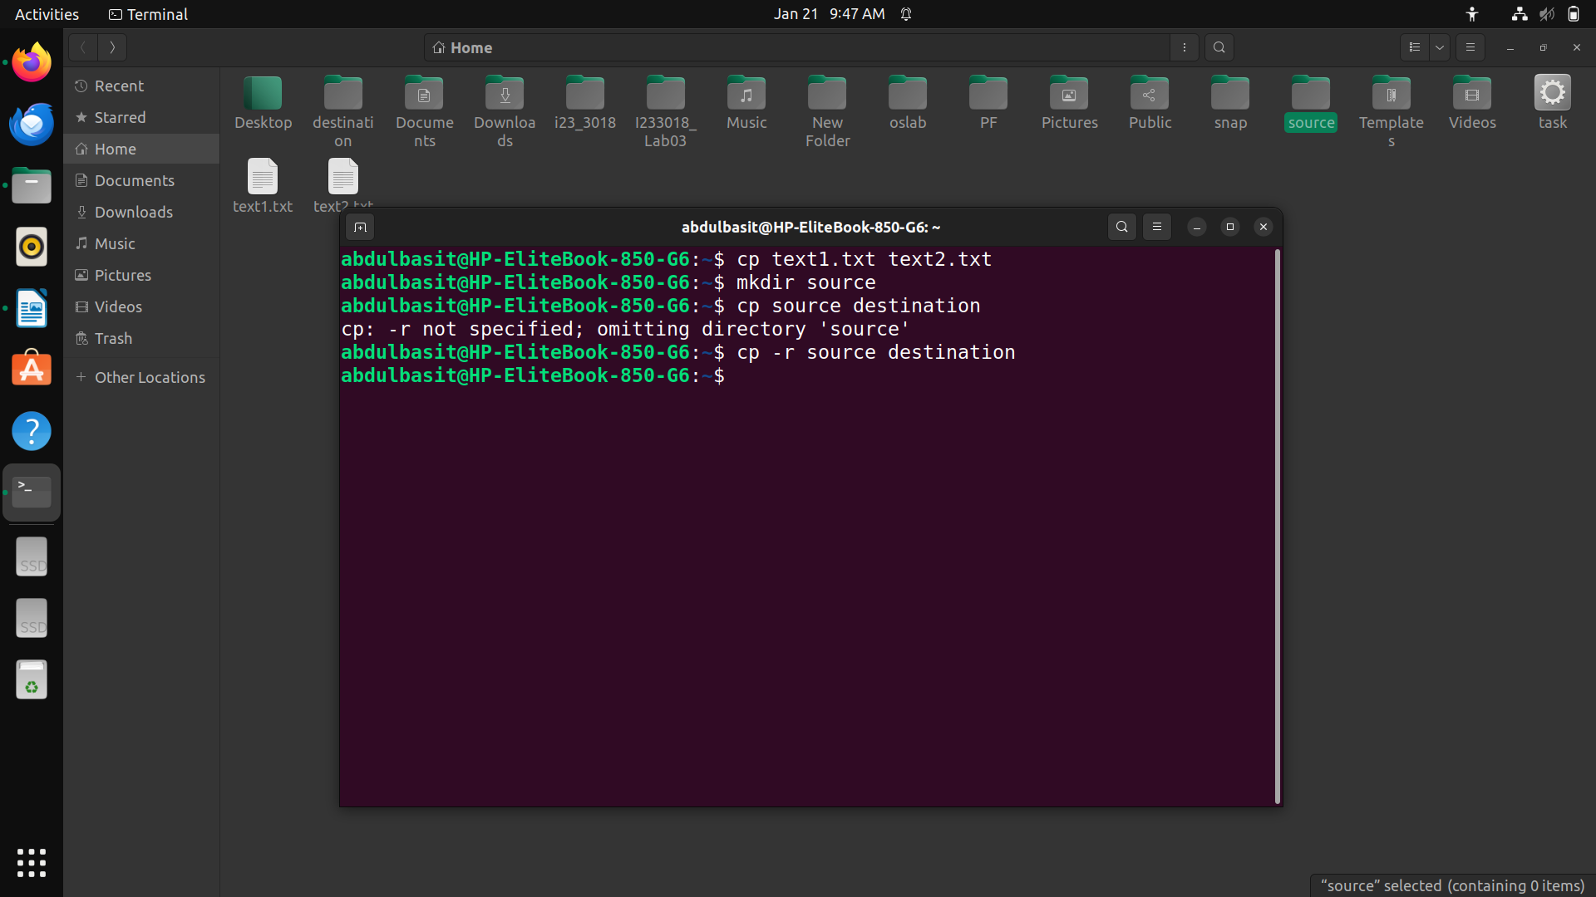

TaskXIV. Copy a file named file1.txt to file2.txt, but only if file2.txt does not already exist.
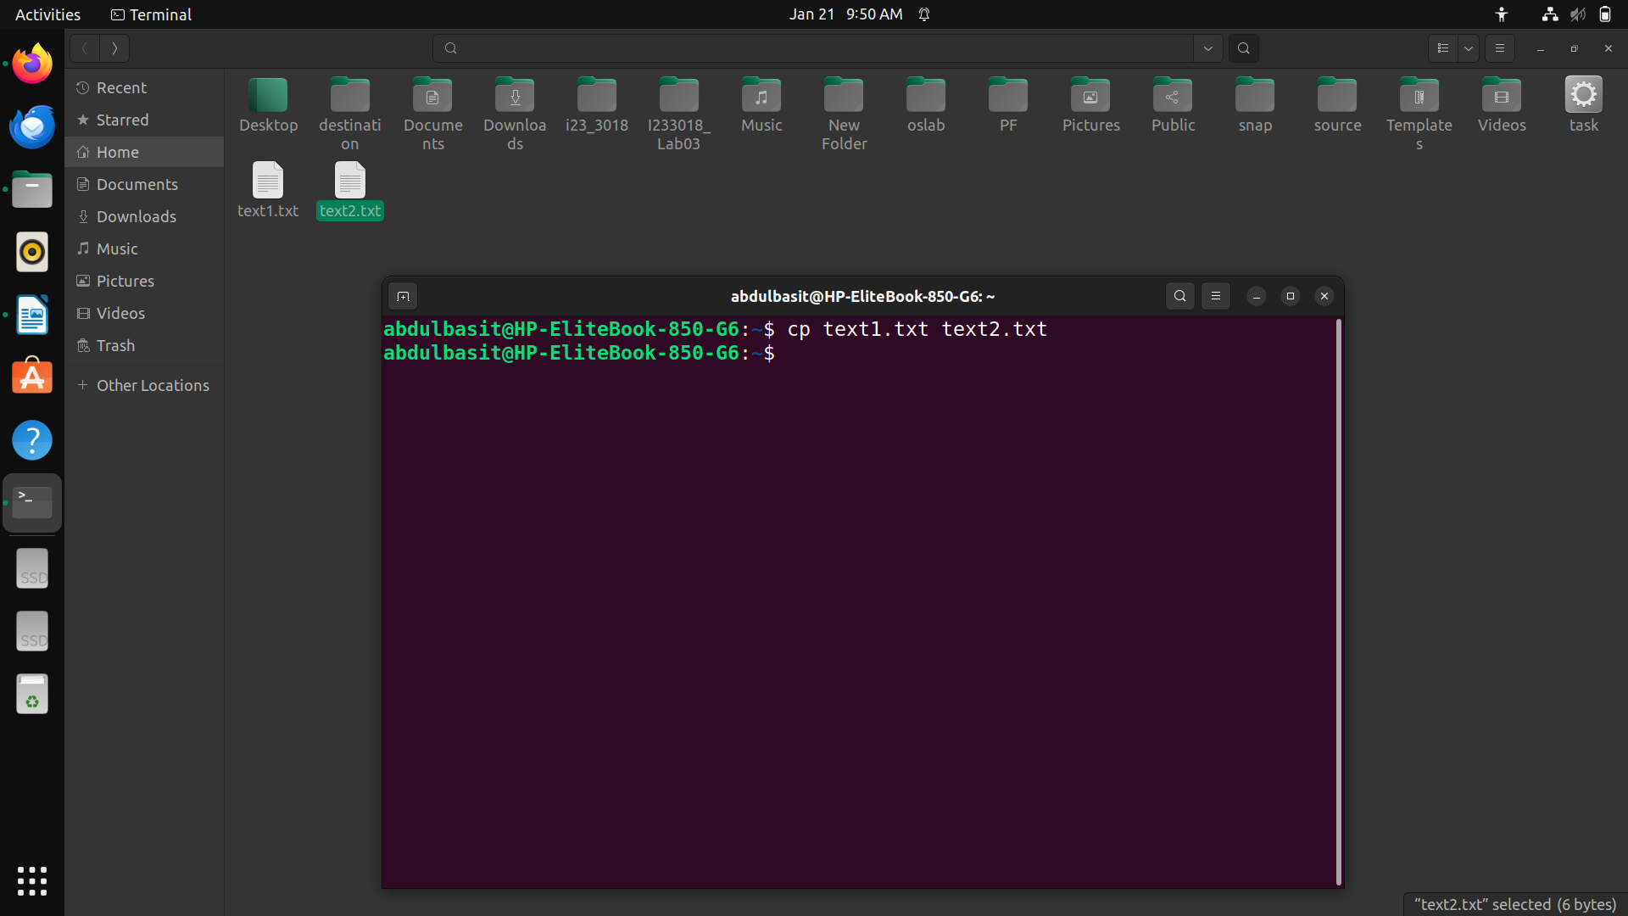
TaskXV. Copy only the contents of source_dir to destination_dir, without copying the source_dir itself.
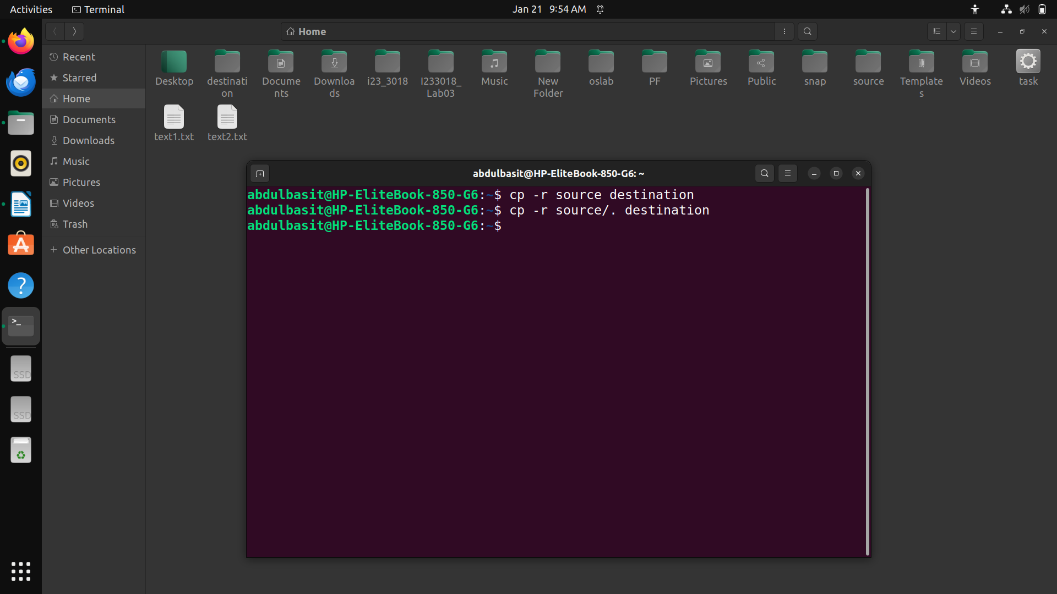

TaskXVI. Move a directory named dir1 to a new location or rename it to dir2
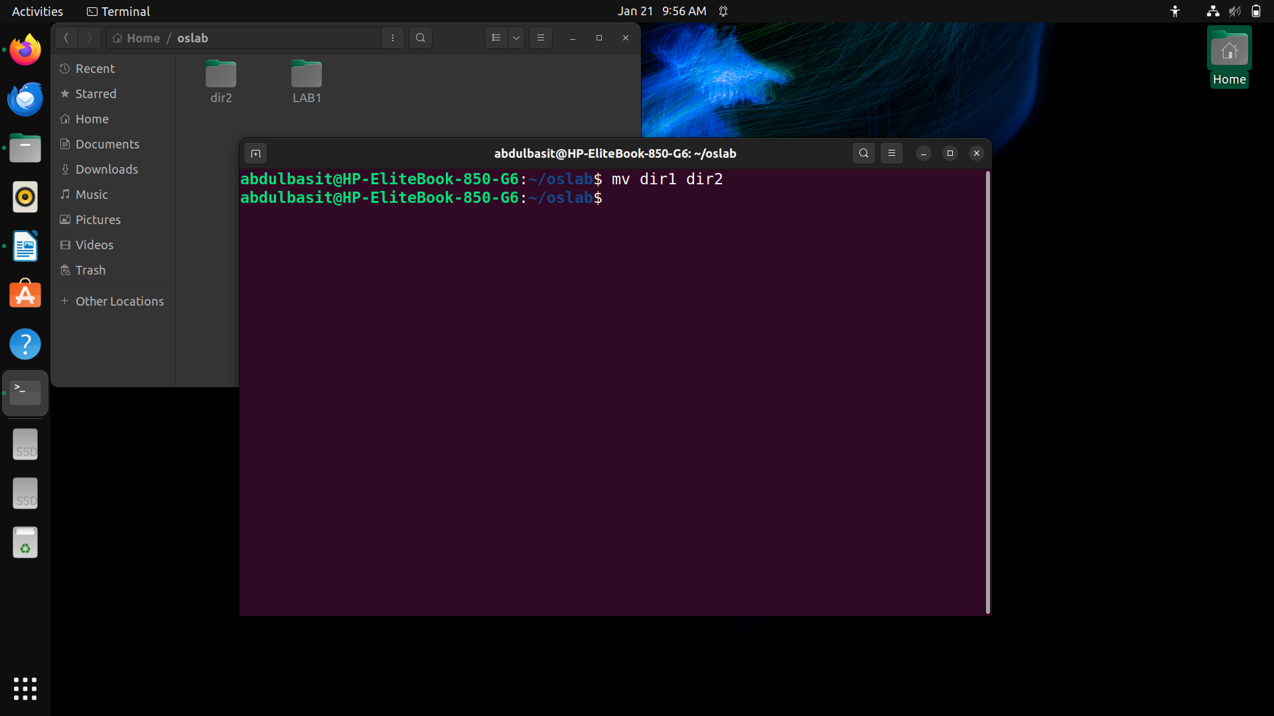
TaskXVII. Change to an absolute path directory, e.g., /home/user/Documents.
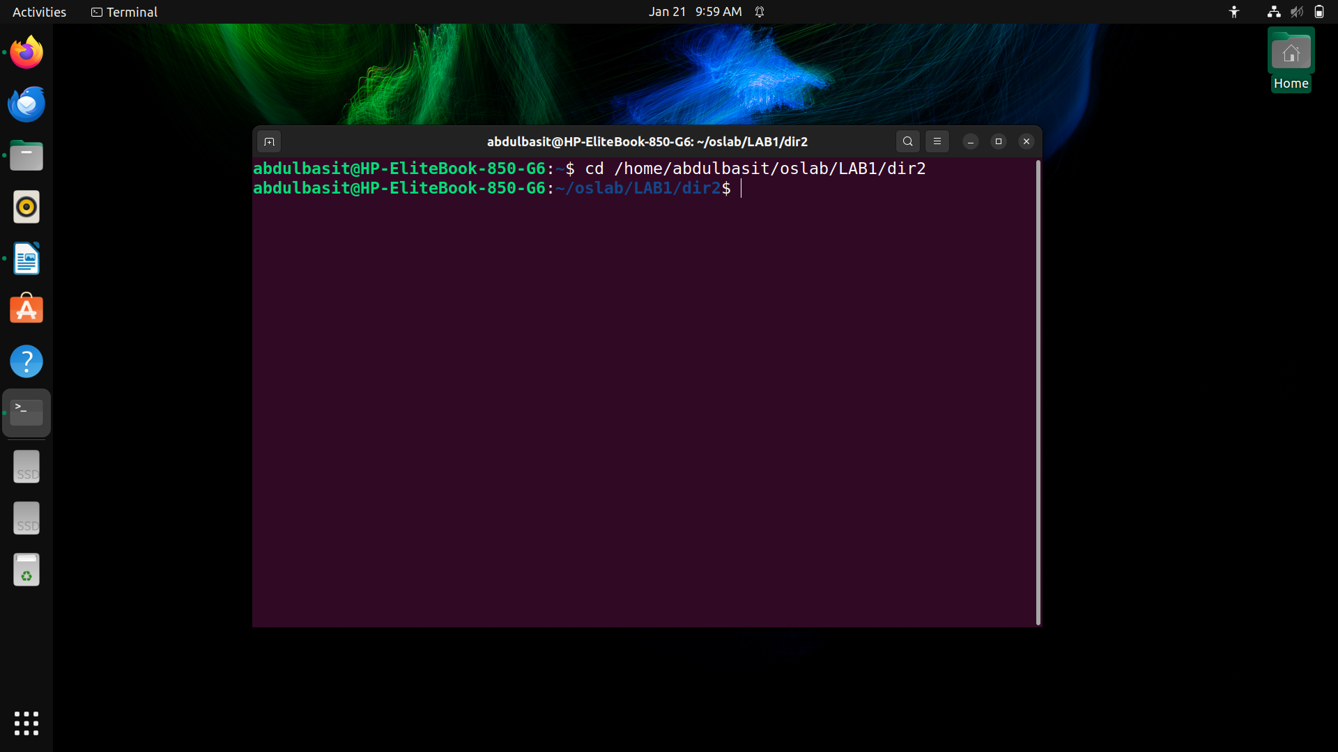
TaskXVIII. Change to the root directory of the filesystem.
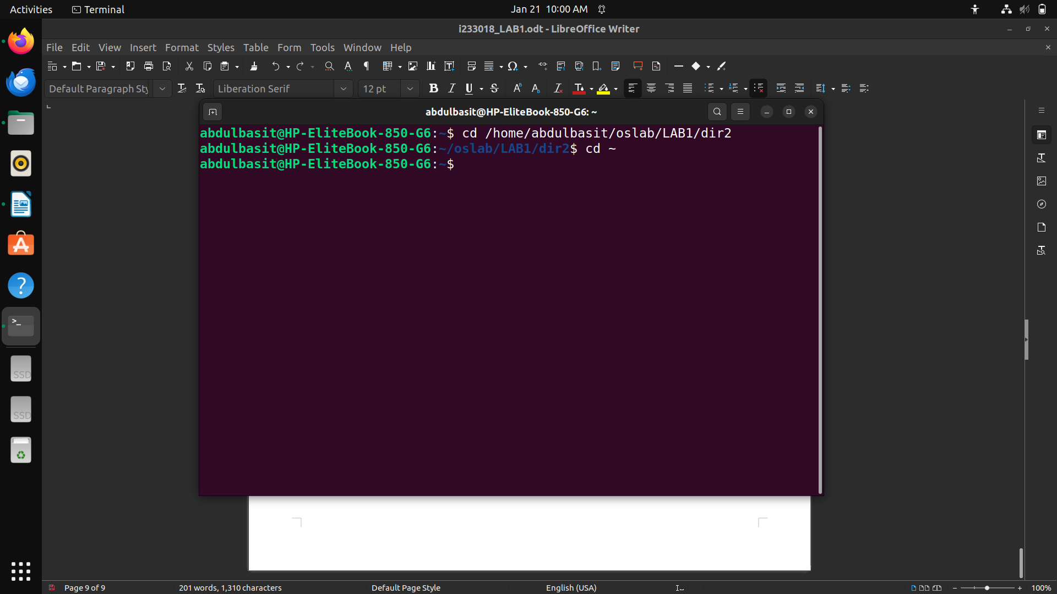
TaskXIX. Change to your home directory using its absolute path.
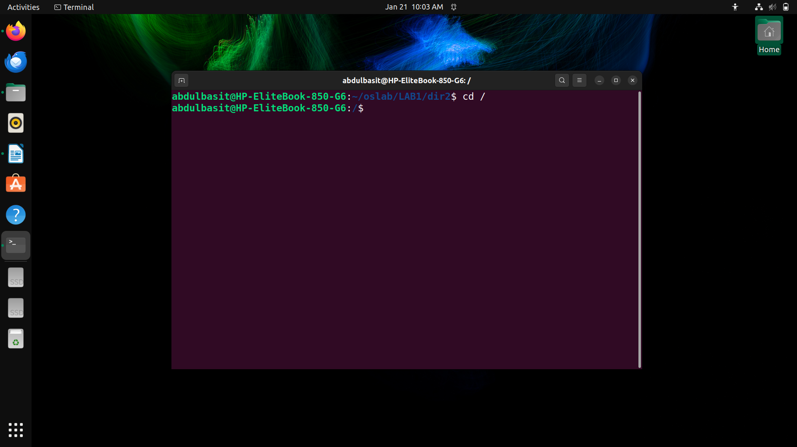

TaskXX. If theres a directory named My Projects under /home/user, navigate to it
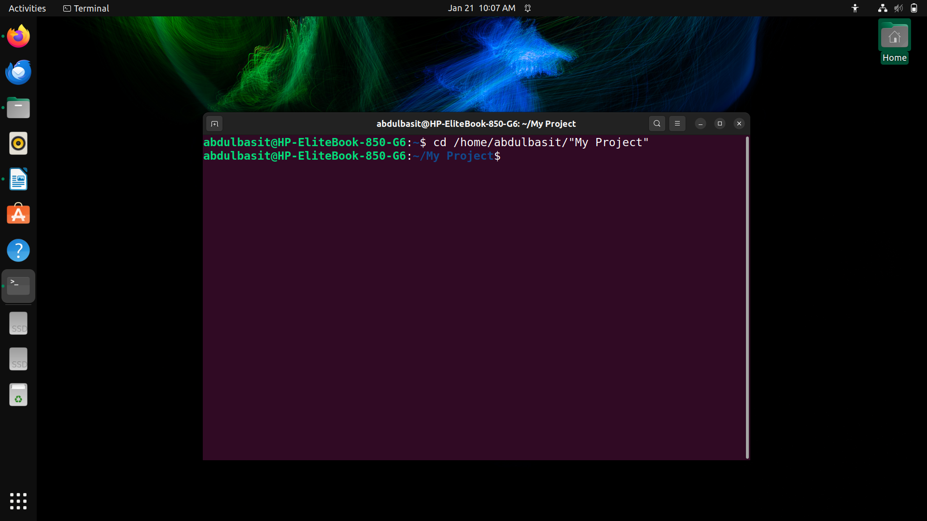
TaskXXI. From your current directory, navigate to a subdirectory named docs.
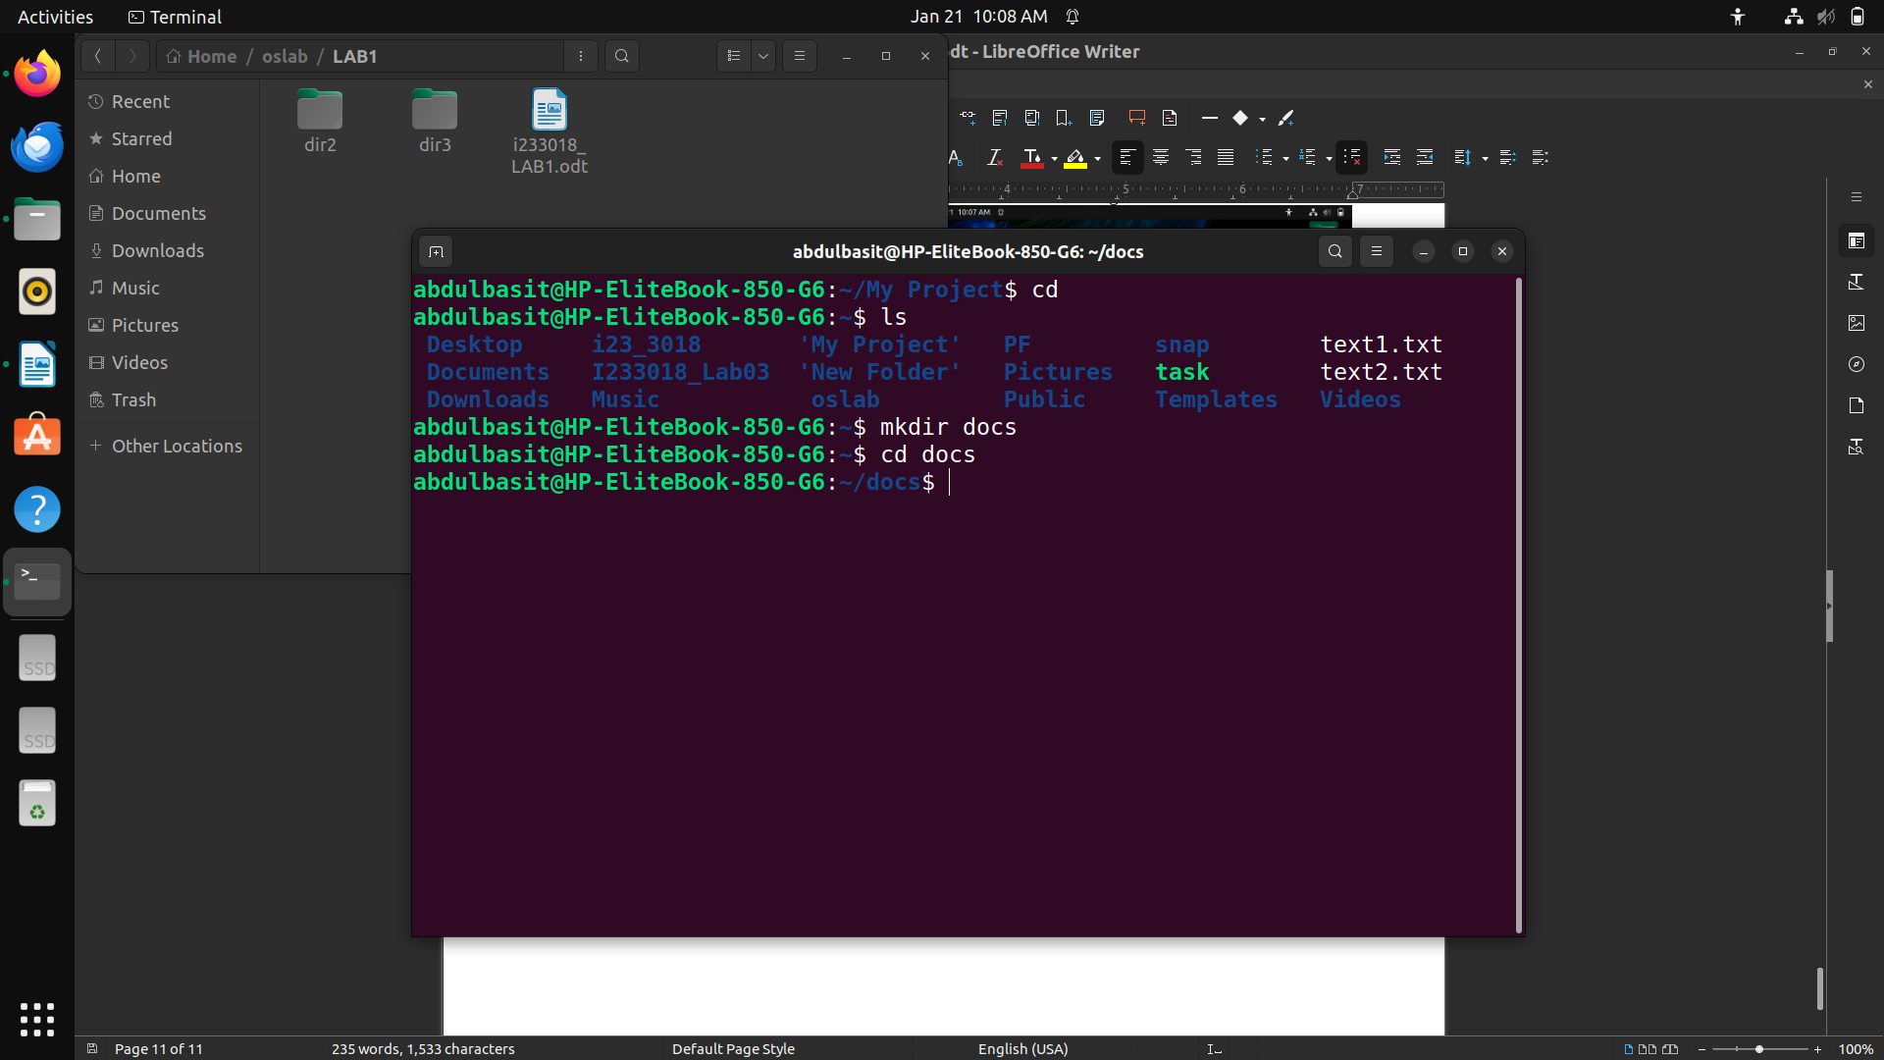

TaskXXII. Move up one directory level from your current location.
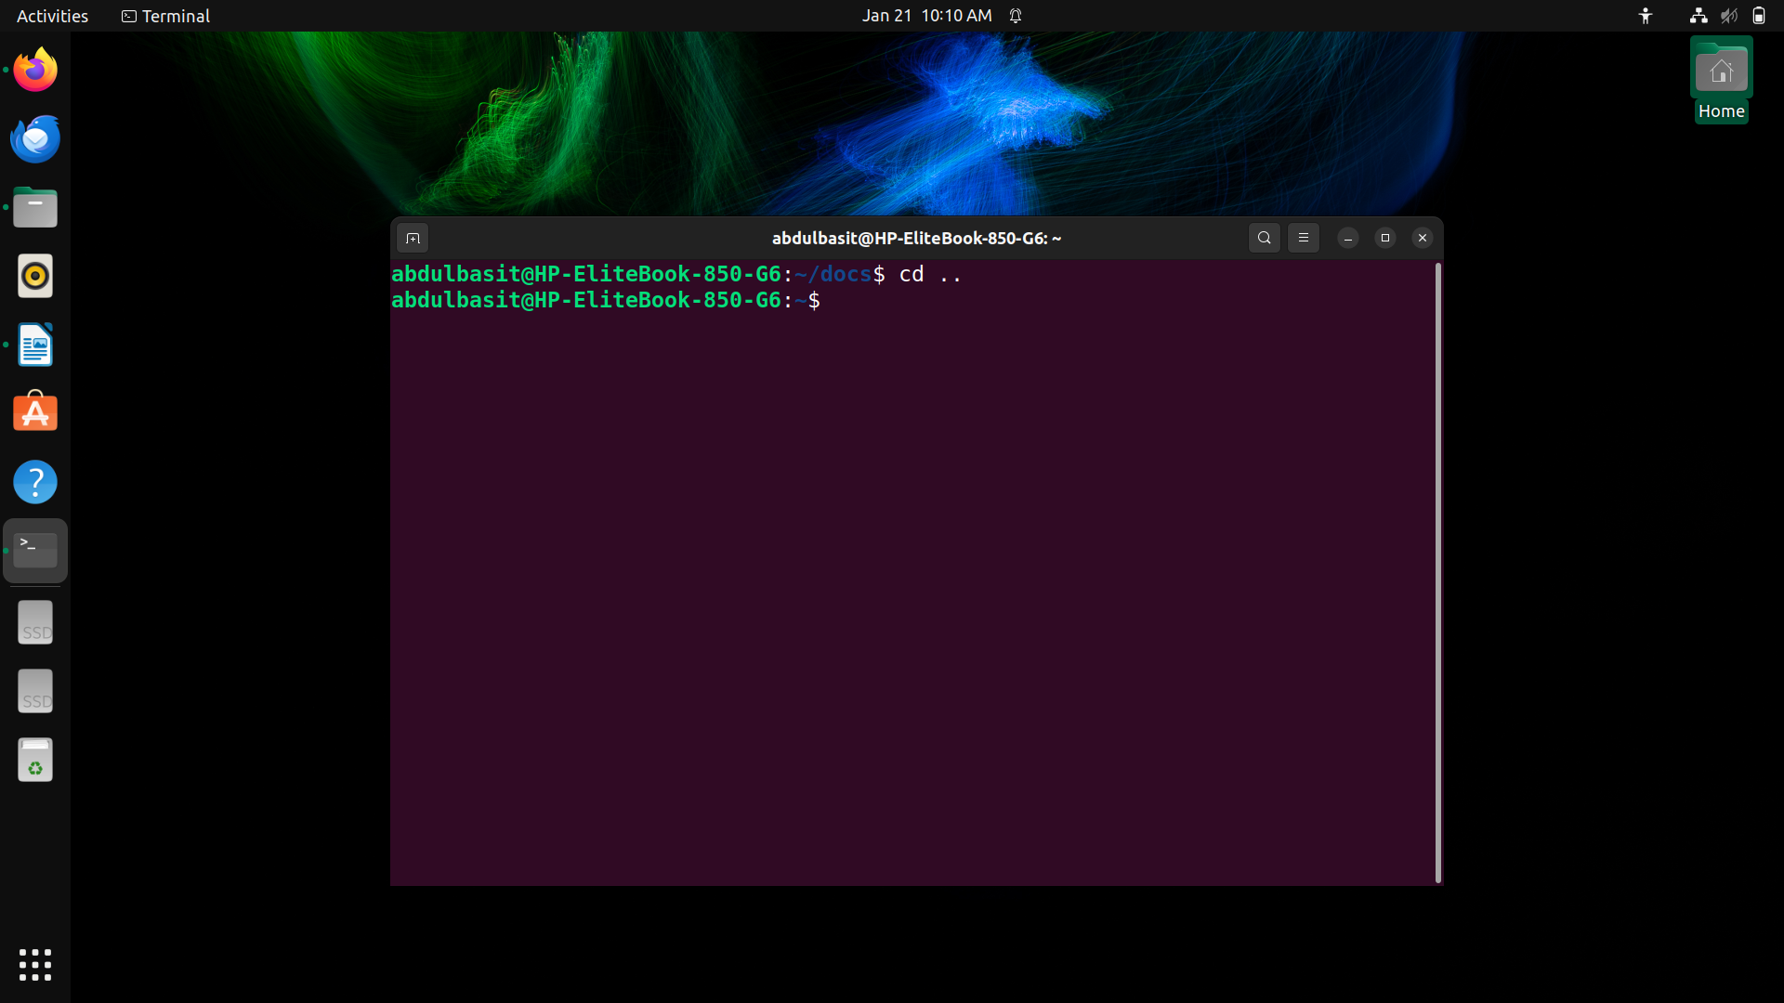
TaskXXIII. Move up two directory levels from your current location.
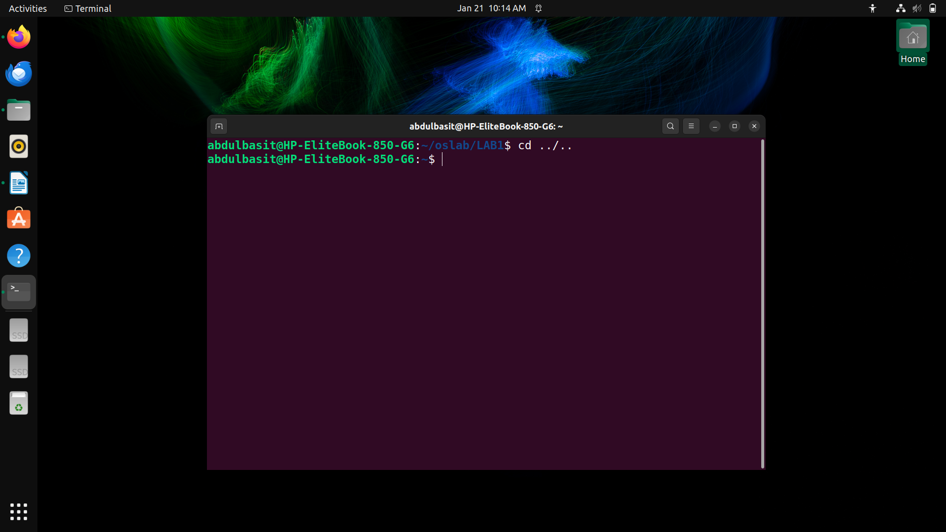

TaskXXIV. If you are in /home/user/Projects/2024, navigate up to Projects and then to a
subdirectory old_projects.

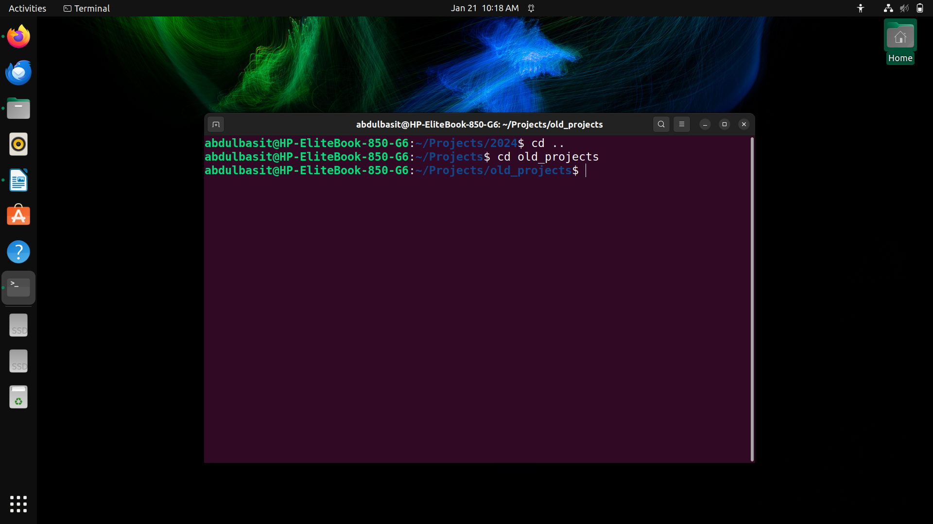
TaskXXV. From any directory, change to your home directory without using the name of home
directory.



